Product Sales by Category
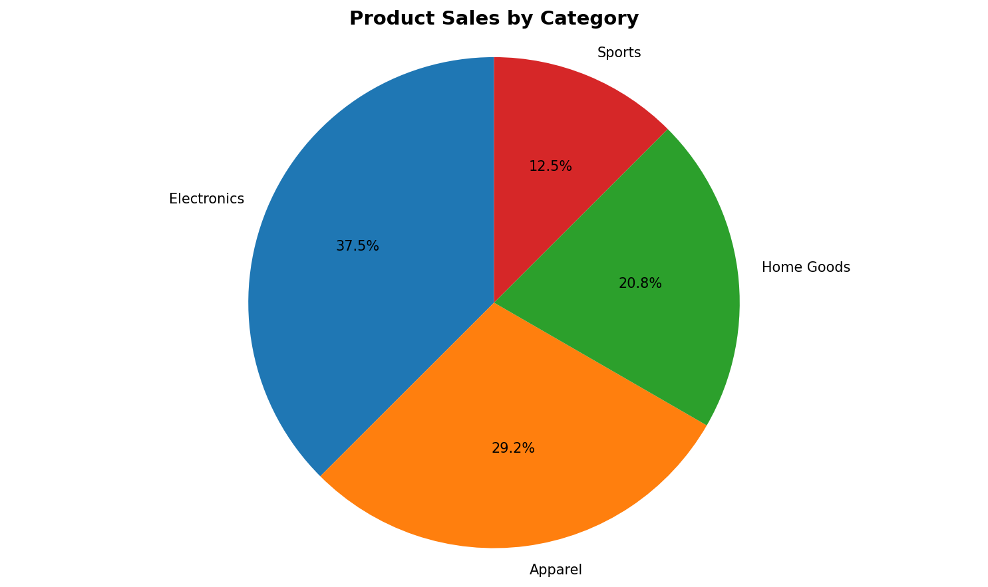
Product Sales by Category
The pie chart shows that electronics make up the largest portion of product sales, followed by apparel, home goods, and sports equipment.

